**Process Optimization Exercise**

**Outline:**

Suggest an optimization for the following **“To be”** process:

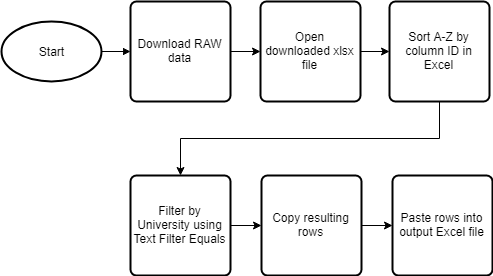

1. Start by downloading the RAW Excel file from the online system
2. Open the downloaded xlsx file with MS Excel
3. Sort alphabetically by the column ID:

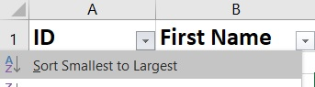

1. Filter by the University (fetched from another application) in the column University using the Text Filter **Equals**:

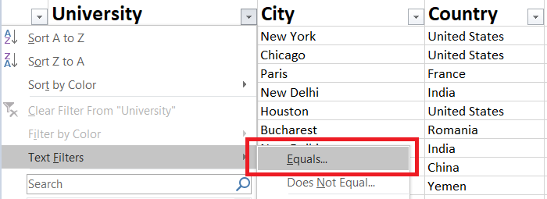

1. Copy the filtered rows in the Clipboard by using CTRL+C
2. Paste into a new Excel file.